UVC-254 works because this wavelength causes lesions in DNA and RNA. Enough exposure to UVC-254 damages the DNA and RNA so that they can't replicate, effectively killing or inactivating a microorganism or virus.
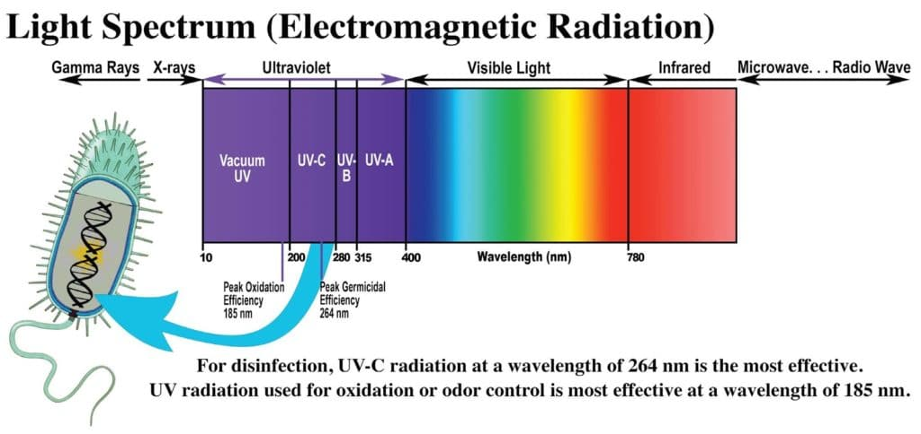
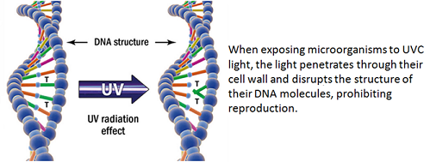
far-UVC (207-222 nm) light is anticipated to have about the same anti-microbial properties as conventional germicidal UV light, but without producing the corresponding health effects. It destroys the protein coat (Capsid), surrounding the pathogen. Should this be the case, far-UVC light has the potential to be used in occupied public settings to prevent the airborne person-to-person transmission of pathogens such as coronaviruses.

